**Create an EBS Snapshot**

* + - * Creating an EBS snapshot
      * Select *Volume* in EC2 dashboard
      * Click on *Action* -> *Create Snapshot*

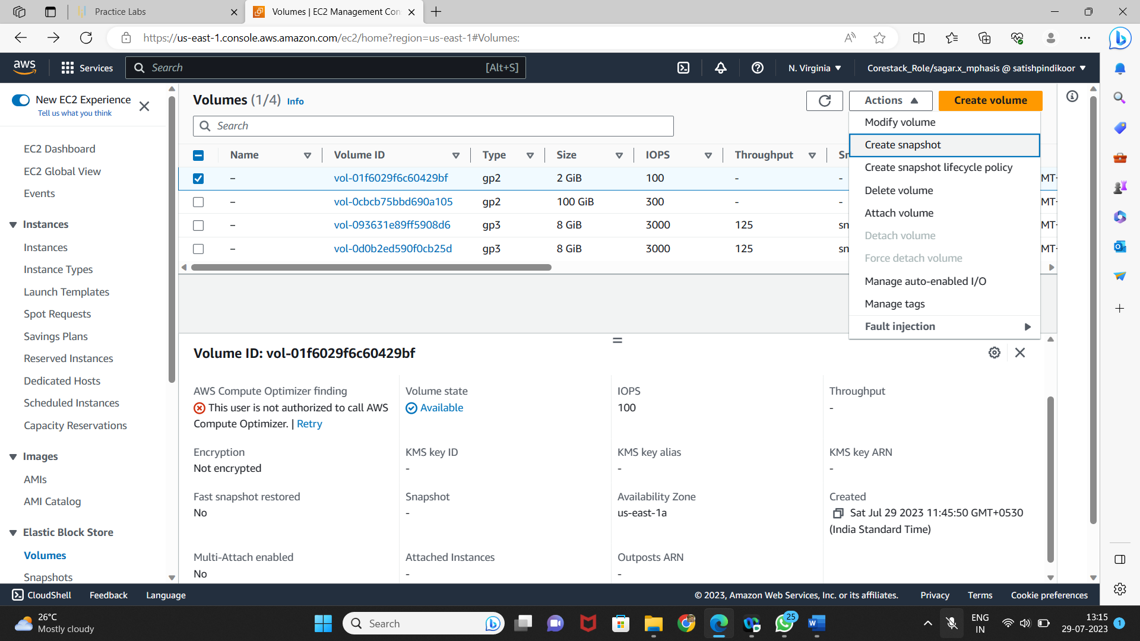

* Add snapshot name, key, and value

